Urban Ecosystem-Based Adaptation for Climate-resilient Development in The Kathmandu Valley

An Implementation Guide for Household Level Urban
EbA Interventions and Monitoring



Prepared By
Project Management Unit
Urban EbA
Year 2024

Ecosystem based Adaptation

Ecosystem Based Adaptation (EbA) makes use of ecosystem services and biodiversity to assist communities in adjusting to the effects of climate change, such as storms, droughts, and flooding. It entails the restoration, preservation, and sustainable management of ecosystems in order to lessen human vulnerability, improve livelihoods, and provide co-benefits for the environment.
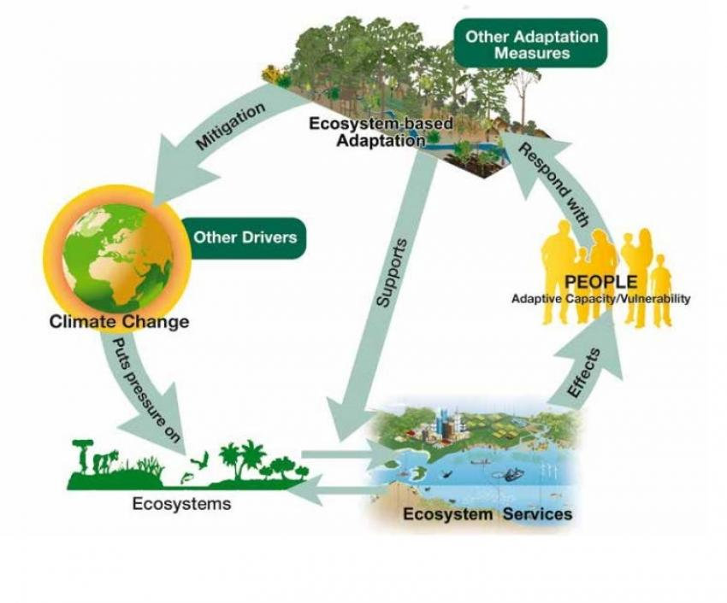
Source: UNEP-UNDP-IUCN Ecosystem Based Adaptation

1.1 Ecosystem Based Problems in Kathmandu Valley

Kathmandu Valley's growing urbanization, which has been unplanned for, has an adverse impact on ecosystem services such as soil stabilization, groundwater recharge including temperature regulation. The ecosystem has caused the temperature to rise, which has led to drought, landslides, and floods. The streets of Kathmandu suffer from heavy floods and sewage overflow during the rainy season. Along with this, rapid development in the Kathmandu Valley is causing a noticeable urban heat island (UHI) effect, which is defined by the substitution of impermeable surfaces like concrete and asphalt for natural landscapes.
To overcome and in the long term eradicate the ecosystem based problems in The Kathmandu Valley, EbA intervention is being implemented. The Least Developed Countries Fund (LDCF) supported project will carry out a number of calculated actions by training communities and the government to promote climate-resilient livelihoods, the initiative hopes to establish a knowledge-sharing platform.

The project's main objectives are replication and sustainability. In addition to integrating EbA techniques into urban policies and planning frameworks, the project has created urban EbA guidelines that the Kathmandu Valley Development Authority (KVDA) will execute.

Various interventions on EbA around Kathmandu Valley entails:
- Rainwater Harvesting for replenishing Groundwater
- Rooftop Farming
- Composting Approach

Rainwater Harvesting for Replenishing Groundwater

2.1 Background

During the monsoon season, Kathmandu's streets experience severe flooding and sewage overflow. This is mainly due to the fact that the majority of the rainwater that falls on the city is not absorbed by the ground. Large amounts of water are directed into rivers and sewage systems by concrete and asphalt. Replenishing rainfall to the earth might help improve Kathmandu's overflow. Additionally, an average family in the Kathmandu Valley can manage 1.5 lakh liters of water annually by using a rainwater collecting procedure, according to several studies. Furthermore, it will replace groundwater that is continuously removed by digging.



Flooded street of Kathmandu Valley
Source: The Kathmandu Post
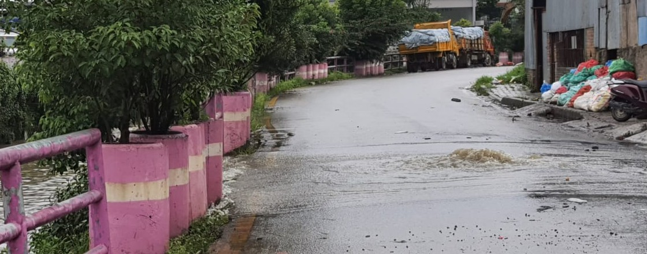

Drainage overflow at Dhobikhola Corridor
Source: The Kathmandu post

2.2 Method of Rainwater Harvesting Systems

Rainwater is collected from the roof catchments of residential or commercial buildings and stored in tanks using a technique known as rooftop rainwater harvesting. In order to fulfill the demands of homes and businesses, collected rainwater can be either kept in a tank or sent to an artificial recharge system. This approach is straightforward, cost-effective, environmentally friendly, and genuinely efficient.
The household use of rooftop rainwater harvesting method includes, flushing toilets, gardening, washing vehicles and cleaning the house.
The excess water can be directed into recharge pits or well to replenish the groundwater.
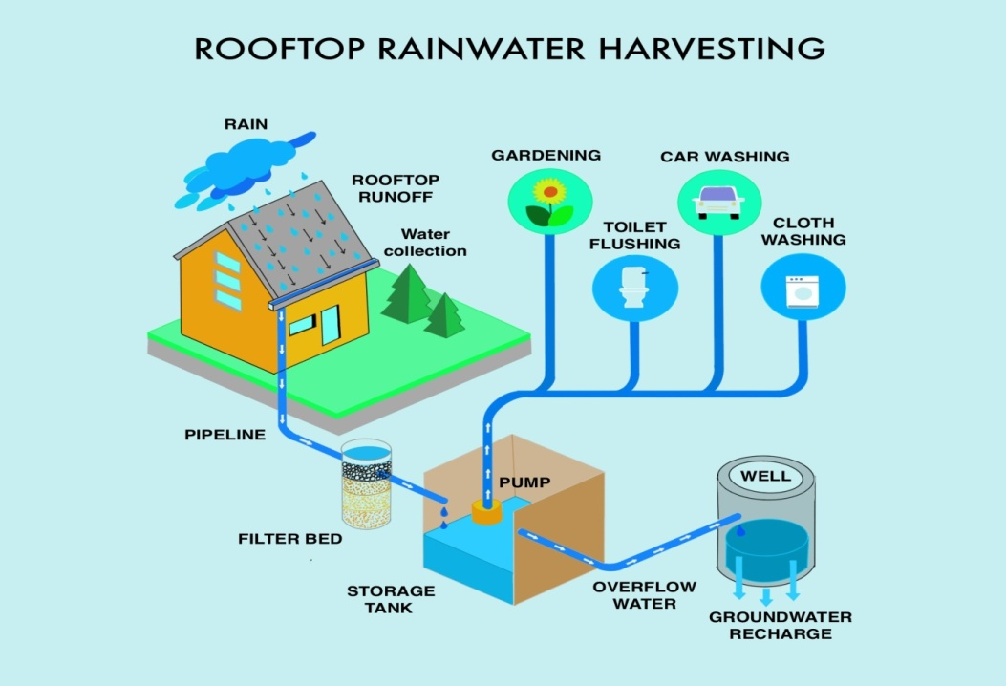
Source: https://gharpedia.com/ Rainwater Harvesting| A Sustainable Solution at Your Doorstep

2.2.1 Benefits

- Increases groundwater supply, which is essential for industry, agriculture, and drinking.
- Aids in the restoration of springs, ponds, and wells that may have dried up as a result of groundwater depletion.
- Controls storm runoff to lessen erosion and floods.
- Minimize governmental and private water infrastructure spending

2.2.2 Steps of Rainwater Harvesting

Step 1: Collection
Water runs off from catchment area such as rooftop, or a road.
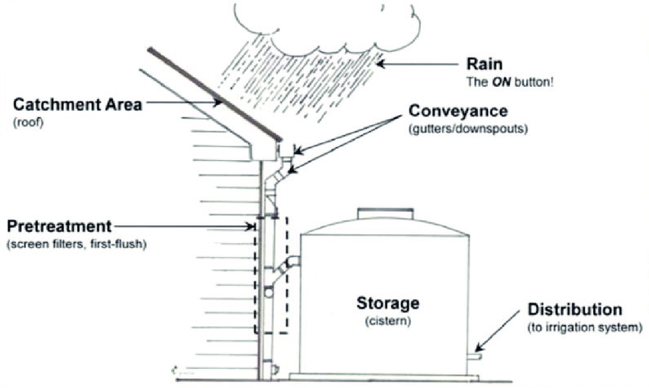
Source: https://www.researchgate.net/figure/Components-of-a-rainwater-harvesting-system-source

Step 2: Conveyance
The water is directed through channels like gutters, pipes or ditches into a storage area.
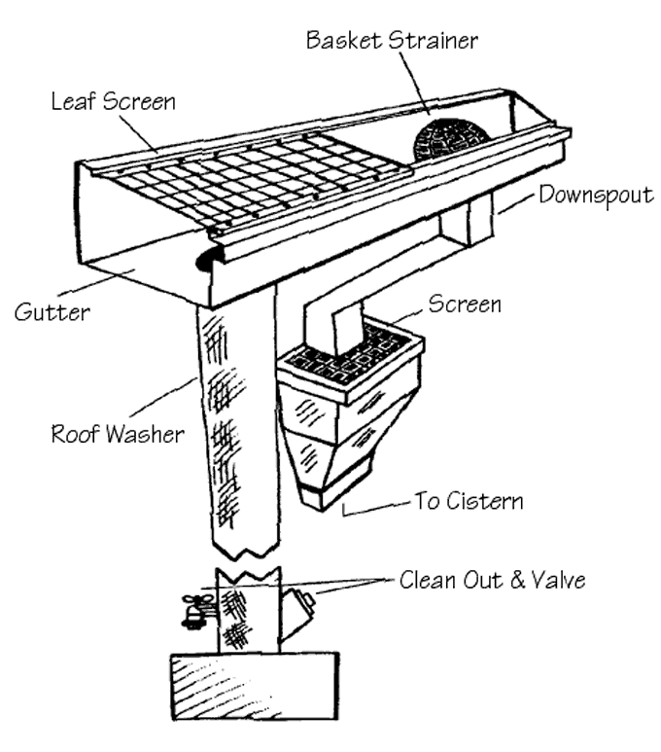
Source: https://www.buildinggreen.com/feature/rainwater-harvesting
Step 3: Filtration
Filters like mesh net are used to remove particles and debris before the water is stored.
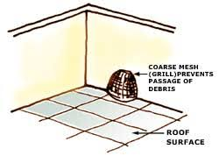
Source: http://www.rainwaterharvesting.org
Further rapid sand filtration is used to remove solids collected from water using layers of sand and gravel.

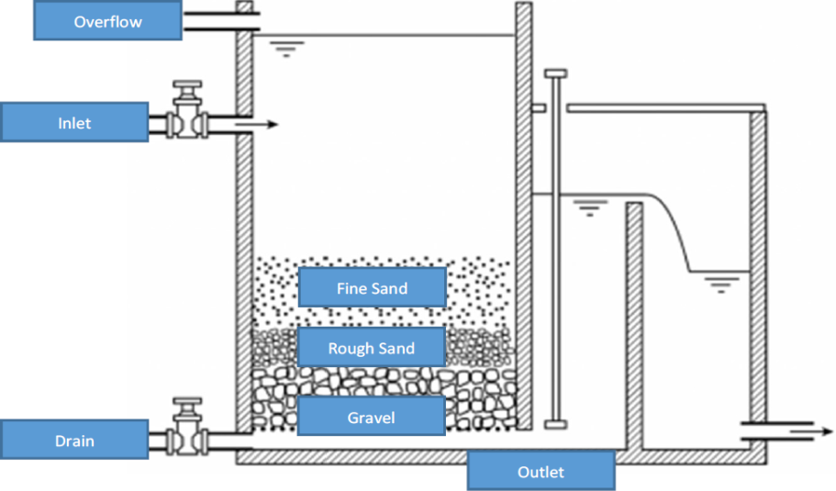
Source: Slow sand Filter (SSWM, 2017)
Step 4: Storage
The water is collected in tanks or large reservoir.

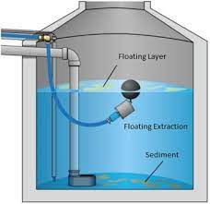
Source: https://www.aqua-lity.co.uk/rainwater-harvesting

Step 5: Usage
The stored water is used for irrigation, toilet flushing or other various uses.

Source: https://www.istockphoto.com/illustrations/rain-water-harvesting-system

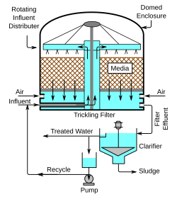
Source: https://en.wikipedia.org/wiki/Biofilter
The stored water can also be used for drinking purpose, after the conduction of bio-filtration.

Rooftop Farming

The practice of cultivating food in the rooftop of buildings is called as rooftop farming. It is usually done using green roof, hydroponics or container gardens.

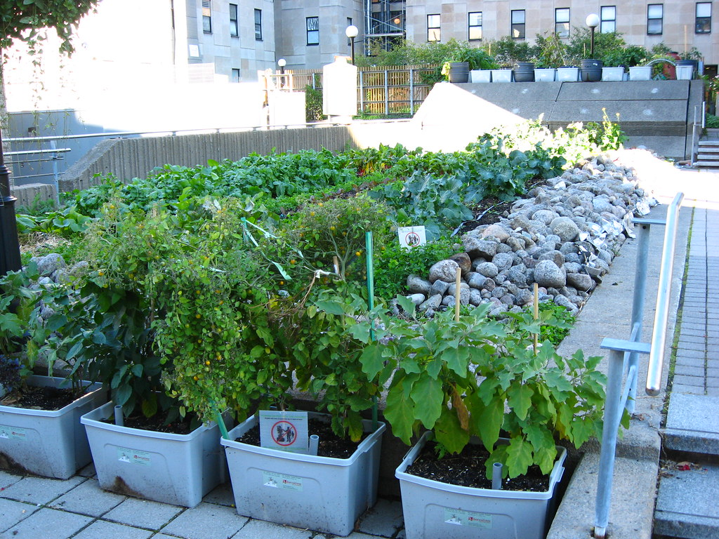

Source: Online Khabar (A guide to rooftop farming)

3.1 Soil-based Methods

3.1.1 Container Gardening

The most popular method of making use of rooftop space is container gardening. It is the straightforward method of cultivating plants in pots or other containers. Because the containers and other raw materials are readily available, it is less expensive. Another efficient option to recycle and reuse used pots, containers, or plastic boxes is to set up a container garden.

3.1.2 Key factors for ideal container gardening

Roof Structure: The setup can be an open rooftop or rooftop greenhouse. The container gardening can be set up in flat or slanted roof, the types of roof structure quite doesn’t matter.
Weather: Too much exposure to the sunlight can damage the plant. Therefore, some shading is necessary using netting or shade cloth. Wind exposure is also strong in the rooftop, so windbreakers should be installed.

Drainage: It is important to design an irrigation and drainage system since container garden consume a lot of water. It should be ensured that the roof has drainage system for escaping of excess water.
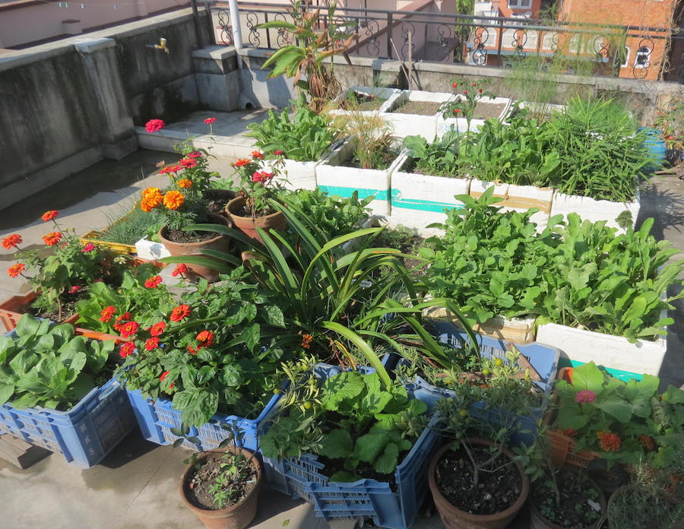

Source: https://verticalveg.com/blog/91275-nepal-rajendras-rooftop-garden

3.1.3 Steps

- Select right pots or container for plants
- Make potting mixture
- Choose right vegetables and fruits
- Place the containers rightly
- Take a good care of the plants

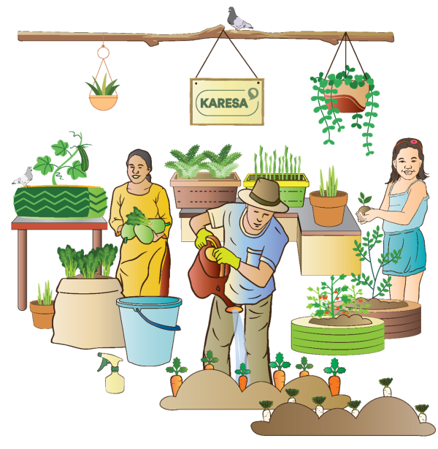

Source: UN-Habitat (Promotion of Urban Agriculture through Rooftop Farming)

3.1.4 Benefits

- Easy access to fresh fruits and vegetables.
- Environmental benefits by reducing urban heat island.
- Promotes sustainability.
- Maintaining of temperature of roof surface and surrounding air.

Composting: A sustainable Approach

Compost is a substance made from decomposing organic matter that resembles soil. Composting is a simple, low-cost, and natural method of recycling plants. The requirements are: some garden area, easy-to-decompose trash, water, and some time.
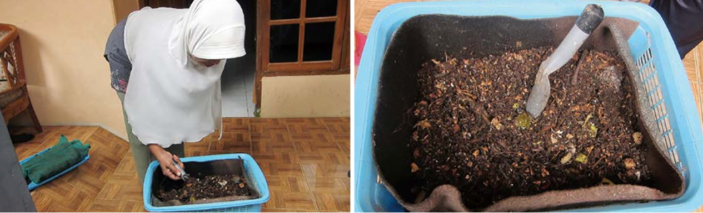
Source: UNEP (Takakura composting basket)

4.1 Why Composting?

- Reduce Negative Environmental Impacts: Composting diverts organic waste away from landfills and open dumping sites, which reduces greenhouse gases emission preventing environment pollution.
- Improve Soil Conditions: Compost serves as a natural fertilizer which enriches the essential nutrients of the soil.

4.2 Process to prepare Compost

- Use a trash bin with tiny openings for air circulation.
- Fix a rod at the bottom of the bin to make it easier to scrape out the manure when it’s ready.
- Add one inch of already prepared manure or mud, which acts as a catalyst for further manure preparation.
- Fill the bin up to 80% with regular household waste, such as vegetable peels and extra food scraps.
- Maintain proper moisture levels to prevent unpleasant odors from developing.
- Place the bin in a dry, sunny location to aid decomposition.
- Manure formation time:
Up to 80 days in winter
About 65 days in summer
- The resulting manure can be used for gardening and growing vegetables, as it is rich in potassium and phosphorus, which are beneficial nutrients for plants.
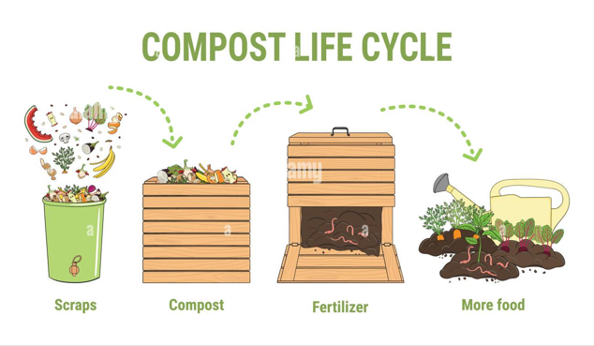

Source: https://www.alamy.com/stock-photo/composting-process

